H.T No
Regulations:
A19

Sreenidhi Institute of Science and Technology
(An Autonomous Institution)
Code No: 7P201 Date: 06-Nov-2021 (FN)

M.Tech I-Year II-Semester External Examination, Oct/Nov - 2021 (Regular & Supplementary)
ADVANCED ALGORITHMS (CSE and CS)

Time: 3 Hours Max.Marks:70

Note: a) No additional answer sheets will be provided.
b) All sub-parts of a question must be answered at one place only, otherwise it will not be valued.
c) Missing data can be assumed suitably.

ANSWER ANY 5 OUT OF 8 QUESTIONS. EACH QUESTION CARRIES 14 MARKS.

Bloom's Cognitive Levels of Learning (BCLL)

Remember | L1 | Apply | L3 | Evaluate | L5
Understand | L2 | Analyze | L4 | Create | L6

 |  |  | BCLL | CO(s) | Marks
1. | a) | What is meant by time and space complexity? | L1 | CO1 | [7M]
 | b) | Write a pseudocode that takes a number and check whether it is a perfect number or not. (A perfect number is one whose sum of its devisors except itself amounts to the given number) | L1 | CO1 | [7M]
2. | a) | Discuss the Brute force approach with its merits and demerits. | L2 | CO2 | [7M]
 | b) | Apply the Brute force approach Algorithm to solve Convex Hull problem. | L3 | CO2 | [7M]
3. | a) | What is the basic concept of Karatsuba long integer multiplication? | L1 | CO3 | [7M]
 | b) | Compute the Huffman coding for the set of symbols shown in below table. | L2 | CO3 | [7M]
  Symbol | A | B | C | D | E
  probability | 0.3 | 0.3 | 0.2 | 0.1 | 0.1
4. | a) | Solve the following set of equations using the Gaussian elimination method?  3x₁ + x₂ + x₃ =11  6x₁ + 4x₂ + x₃ =29  x₁ + x₂ + x₃ =7 | L3 | CO4 | [7M]
 | b) | Explain the Floyd-Warshall algorithm on the weighted, directed graph of below.  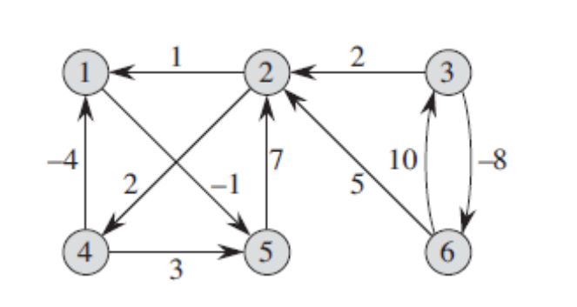 | L6 | CO4 | [7M]
5. | a) | Explain the naïve string-matching techniques to find the given pattern.  Text = 1011101110  Pattern = 111  Find all the Valid Shift | L6 | CO5 | [7M]
 | b) | Solve the following LPP:  Maximize Z = 7 x₁ + 3x₂ subject to the following constraints:  2x₁ + 6x₂ <= 24  6x₁ + 2x₂ <= 24  x₁, x₂ >= 0 | L3 | CO5 | [7M]
6. | a) | Explain the classes of NP-hard and NP-complete. | L2 | CO6 | [7M]
 | b) | Summarize the satisfiability problem | L6 | CO6 | [7M]
7. | a) | Differentiate between homogeneous and non- homogeneous recurrence equations? | L4 | CO1 | [5M]
 | b) | Write a selection sort Algorithm | L1 | CO2 | [5M]
 | c) | Use the Strassen method to multiply the following matrix.  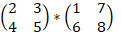 | L3 | CO3 | [4M]
8. | a) | Write the Crout’s procedure for finding LU decomposition. | L1 | CO4 | [5M]
 | b) | Define the following terms:  Feasible regions convex set redundant constraints and extreme points. | L1 | CO5 | [5M]
 | c) | Explain reproduce cook's theorem. | L2 | CO6 | [4M]

-- 00 -- 00 –

